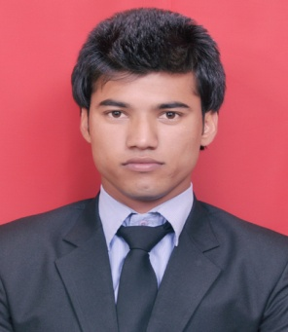**CURRICULUM VITAE**

**Jitender Thakur**

MBA-Pursuing

Career Point University Hamirpur

Contact No. - 9736558685, 8988314610

Email ID: [jitu39195@gmail.com](mailto:jitu39195@gmail.com)

**Career Objective:**

To work for a firm in a professionally driven environment that can utilize my knowledge, skills and enable me to grow with full potential while fulfilling organizational goal.

**Academic Credentials:**

|  |  |  |  |
| --- | --- | --- | --- |
| **Qualification** | **Board/University** | **Batch/Year** | **Percentage/Grade/Pointer** |
| MBA(Pursuing) | Career Point University Hamirpur | 2013-2015 | CGPA up to 3rd Semester 8.93  Result Awaited 4th semester |
| Bachelor of Commerce | Himachal Pradesh University Shimla | 2013 | 60% |
| Intermediate(Commerce) | Himachal Pradesh Board of School Education, Dharamsala | 2010 | 66% |
| High School | Himachal Pradesh Board of School Education, Dharamsala | 2008 | 70% |

**Summer Internship:**

* Company Name: - NHPC (Project: Parbati Stage-II, Nagwani, District-Mandi, Himachal Pradesh)
* Duration: - 6 Weeks (12th June 2014 to 24th July 2014)

**Key Responsibilities during Summer Internship:**

* To study the manuals of organization.
* To help to verify the documentary evidences.
* To order and number office files.

**Project Undertaken during MBA:**

* Internet Banking.

**Computer Proficiency:**

* Proficiency inMicro Soft Office.
* Internet Browsing.
* Basic Knowledge of computer.

**Extra- Curricular Activities:**

* Student’s Cell Placement Coordinator at Career Point University Hamirpur.
* Participated in India International Trade Fair 2015 (New Delhi) and Knowledge Expo 2015 (Greater Noida) on behalf of National Innovation Foundation.
* Attended seven days workshop on Micro Small and Medium Enterprises Workshop at Career Point University, Hamirpur.

**Achievements & Accomplishment:**

* Executive Member of Student House in Career Point University Hamirpur.
* Hostel Head Boy in Career Point University, Hamirpur.
* Actively participated in various sports and cultural activities for inter school , college and university level in game like cricket and badminton.

**Interpersonal Skill:**

* Ability to build up relationship and set up trust.
* Confident and determined.
* Consistency.
* Comfortable in team leading.
* Ability to manage up with different situation.

**Areas of Interest:**

* To play cricket.
* Interacting with people.
* Reading books (Management, fiction, inspirational books)

**Reference:**

* Mr. Sanjay Thakur Assistant Professor, in Management, Career Point University. (8261001330).
* Mr. Lek Raj Verma Assistant Professor, in Management, Career Point University. (9318054701).

**Personal Detail:**

|  |  |
| --- | --- |
| Father Name | Sh. Chuni Lal Thakur. |
| Permanent Address | Village – Shira, Post Office – Manglore, Tehsil- Banjar, District- Kullu, State- Himachal Pradesh, Pin Code-175123. |

Nationality Indian

Marital status Unmarried

**Declaration**

I do hereby declare that above information is true to the best of my knowledge.

Jitender Thakur